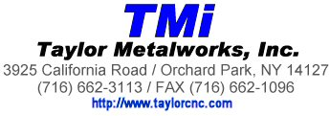

Updated 8-4-2026

Employers are no longer required to distribute Form 1095-C (Employer-Provided Health Insurance Offer and Coverage document) to all full-time employees. Instead, these forms only need to be provided upon request.

The 1095-C contains detailed information about the health care coverage offered by your employer. It is NOT needed to file your taxes.

If you would like a copy of your 1095-C, please contact:
Diana Harenza, HR Manager; dharneza@taylorcnc.com, 716-662-3133 ext 133, or mail to Taylor Metalworks Inc, 3925 California Road, Orchard Park, NY 14127.

